Compass MED D - Coverage Gap Discount Program

General Information
Key Points
Applicable Beneficiary
Applicable Claim
Benefit Stage Qualifiers
Generic Co-Insurance
Manufacturer Brand Discount
Brand Co-Insurance
NON-Participating Manufacturers
Identifying the Coverage Gap in Compass
Retroactive Claim Adjustments
Related Documents

Description: The guidance within this document will cover all aspects of the MED D Coverage Gap Discount program, will assist the CCR in identifying these aspects in Compass and provide guidance on how to address questions from the beneficiary.

Note: This document is for research purposes only, the Gap Coverage discount program ended at the end of 2024.

General Information

The MED D Gap Coverage Discount Program and gradual closure of the coverage gap is a result of Patient Protection and Affordable Care ACT. As of 2020, there is no longer a donut hole; however, the beneficiary may experience a change in cost share when they reach the initial coverage limit (total drug spend) of $4,660 in 2023. The beneficiary will only be responsible for up to a maximum of a 25% coinsurance in the coverage gap phase or their plan copay/coinsurance if lower (based on plan design).

The Coverage Gap Discount Program (CGDP) provides a manufacturer discount for Brands and coverage of Generic medications during the coverage gap phase of the Medicare prescription drug benefit.

From Plan Year 2020 and moving forward:
- Drug manufacturers provide a 70% price discount to applicable Part D beneficiaries for brand drugs and biologics (including biosimilars) purchased during the coverage gap. Plans may also subsidize this discount for beneficiaries with enhanced plans.
- Biosimilars are eligible for a manufacturer gap discount.
- Beneficiaries who have enhanced coverage may have lower cost shares in the coverage gap.
- The gap discount program is not applicable for LIS beneficiaries since they do not experience a coverage gap (they are specifically excluded).

For plan year 2025 and moving forward:
- The Gap Coverage discount program ended at the end of 2024.
- Beneficiaries pays 25% for generic drugs and 25% on brand drugs for a Defined Standard benefit. If a plan offers enhanced cost-sharing, they will pay these cost-shares until their $2,000 out of pocket is met.

Top of the Document

Key Points

The following key points provide a high level overview of the Coverage Gap Discount Program:
- Beneficiary must be eligible to receive gap discount
- Claim must be considered an “applicable drug” to receive gap discount
- At least part of the claim must fall within the coverage gap
- Coverage Gap Discount applies to drugs classified as brands, biologics, or biosimilars by the FDA
- Discount may reduce the patient pay at point of sale and on beneficiary or physician submitted paper claims; depending on the Part D benefit design
Note: Only true for plans with enhanced coverage in the gap that are not EGWPs.
- Defined Standard Basic generic gap co-insurance is 25% in 2023.
- Defined Standard Basic brand gap co-insurance is 25% for 2023 when combined with the manufacturer gap discount (if the claim is not eligible for a gap discount, 95% coinsurance will apply).

Top of the Document

Applicable Beneficiary

Applicable Beneficiary means an individual who, on the date of dispensing a covered Part D drug:
- Is enrolled in a prescription drug plan or an MA-PD plan
- Is NOT enrolled in a qualified retiree prescription drug plan
- Is NOT entitled to an income-related subsidy under 1860D-14(a) (Example: Beneficiary is not LIS)
- Has reached or exceeded the initial coverage limit under section 1860D-2(b)(3) during the year
- Has not incurred costs for covered Part D drugs in the year equal to or greater than the annual out-of-pocket threshold

Top of the Document

Applicable Claim

Characteristics of an applicable claim:
- Submitted drug has been approved by the FDA based upon either an NDA or BLA drug application type
- Drug Manufacturer is covered under a Manufacturer Discount Agreement with CMS
- Medicare is the primary payer
- Claim was NOT submitted as a compound
  - Compound claims are non-applicable, will not receive a gap discount, and the 25% generic coinsurance (2023) will be assessed if enhanced gap cost sharing is not applied
- Claim was either submitted electronically by the pharmacy, or via paper claim by the pharmacy, beneficiary, or their physician

Top of the Document

Benefit Stage Qualifiers

Benefit Stage Qualifiers (BSQ) are informational values CVS Caremark sends in our Part D claim responses in conjunction with Benefit Stage Amounts (when applicable) and they provide information to both the pharmacy and subsequent payers about the claim.
- The following BSQs provide information about benefit phase(s) for paid claims for a Part D drugs covered under the Part D plan:
  - 01 - Deductible
  - 02 - Initial Coverage
  - 03 - Coverage Gap
  - 04 - Catastrophic
- The following BSQs communicate somewhat different information:

BSQ Value | Description
50 | - This qualifier is returned if the claim was submitted the Part D plan and paid; however, the coverage was actually provided by the plan’s Part C coverage rather than paying under Part D.  - An example of this would be a paid claim for a Part B drug.
51 | - This qualifier is returned with a Medicare Part B paid claim when a Beneficiary is identified as a Qualified Medicare Beneficiary (QMB). When this BSQ is returned, the pharmacy should not attempt to collect a cost-share from the beneficiary, but instead should attempt to bill COB to Medicaid coverage.
61 | - When a claim for a Part D drug is submitted to the Part D plan and rejects, then is automatically passed (through single transaction coordination of benefit processing) to an Enhanced Wrap Benefit and pays, CVS Caremark will return BSQ 61 to communicate that although the claim paid, it paid under an Enhanced Wrap Benefit rather than Part D.
62 | - When a claim for a Non-Part D drug is submitted to the Part D plan and rejects, then is automatically passed (through single transaction coordination of benefit processing) to an Enhanced Wrap Benefit and pays, CVS Caremark will return BSQ 62 to communicate that although the claim paid, it paid under an Enhanced Wrap Benefit rather than Part D.
63 | - When a claim for a Non-Part D drug is submitted to the Part D plan and rejects, then it is automatically passed (through single coordination of benefit processing) to the Medicaid plan for Dual Demonstration plan. It was paid under Medicaid benefit only of the Medicare/Medicaid (MMP) or dual demonstration plan.
70 | - When a claim for a Part D drug is not paid for by the Part D plan, and the beneficiary paid for the negotiated/contracted cost of the drug, such as when quantity limits have been exceeded or the drug is not on the plan’s formulary.
80 | - When a claim for a Non-Part D drug is not paid for by the Part D plan, and the beneficiary paid for the negotiated/contracted cost of the drug. This is only returned for Part D excluded drugs.
90 | - Part D plans occasionally cover Over the Counter drugs, and drugs that don’t qualify for coverage under Part D but can be covered under a Part D plan as Enhanced Coverage.  - When a claim for one of these products is submitted to the Part D plan and pays, CVS Caremark will return BSQ 90 to communicate that although the claim paid, it was as an Enhanced or OTC drug. This helps the pharmacy and subsequent payers understand that the claim will not count toward the beneficiary’s Part D benefit accumulations.

Top of the Document

Generic Co-Insurance

The defined basic benefit generic co-insurance for NON-LIS beneficiaries in the coverage gap phase of their benefit will be 25% in 2023.
- The sponsor will pay the remaining 75%

If the Part D plan offers enhanced generic cost sharing in the coverage gap, the plan’s generic co-pay or co-insurance will be applied.
- The 25% defined basic coinsurance is not applicable in this situation

Note: The drug's appropriate tier cost share will be applied and this may not be the generic cost share.

Example: Generic specialty drug which is on the 4th tier of the plan's formulary. The cost share associated with tier 4 would be applied.

Coverage for Generics in the Gap:
- Applies to retail, mail, electronic, batch and paper claims submitted by beneficiary, physician or pharmacy
- NON-LIS Medicare Part D beneficiaries in the coverage gap
- Generic drugs are defined as those that have been approved by the FDA based upon an Abbreviated New Drug Application (ANDA) and are irrespective of brand/generic status assigned by drug data vendors
- Part D plans may provide an enhanced alternative (EA) benefit which gives additional gap coverage
- Gap benefit for generics must be actuarially equivalent or significantly more than the defined basic 25% generic coinsurance
- The following will also be treated as generics in the coverage gap:
  - Covered Part D drugs and products that don’t have a drug application type (Example: Diabetic supplies used for the administration of insulin)
  - Compounds

Top of the Document

Manufacturer Brand Discount

Medicare Part D claims are eligible to receive a 70% Manufacturer Discount in 2023 on drugs which the FDA and CMS consider to be brand name drugs.
- Discount will be funded by the drug’s manufacturer
  - Part D plan will pay the discount at Point of Sale and the manufacturer will reimburse the plan
- Manufacturer must sign a discount agreement with CMS to participate
  - If the manufacturer does not sign an agreement, their brand Part D drugs will no longer be covered under the Part D benefit

Does the 70% in 2023 Discount Apply to All Brand Name Drugs?
- For the purpose of determining whether the gap discount applies, brand drugs are defined as those which have been approved by the FDA based upon New Drug Application (NDA) = Y or Biologics License Application (BLA)
Note: This is irrespective of brand/generic status assigned by drug data vendors.
- CMS expects all brand manufacturers of Part D drugs to sign a discount agreement.
  - Part D brand drugs not under a manufacturer agreement cannot be covered under a Part D plan.
  - The drug’s Med D status will be changed to Med D = N.

Top of the Document

Brand Co-Insurance

The defined basic benefit brand co-insurance for NON-LIS beneficiaries in the gap phase of their benefit is defined as 95% in 2023; however, when the gap discount also applies the beneficiary’s coinsurance is actually 25% in 2023.
- The sponsor will pay the remaining claim amount
  - Manufacturer pays 70% of ingredient cost and sales tax, beneficiary pays 25% of total coverage gap claim cost, and the plan pays the remainder (5% in 2023)
- The defined basic brand co-insurance will continue to remain as 25% as initiated in 2020 and beyond; until CMS specifies otherwise.

If the Part D plan offers enhanced brand cost sharing in the coverage gap, the plan’s brand co-pay or co-insurance will be applied.
- The 95% (25% with gap discount) defined basic coinsurance is not applicable in this situation

Note: Drug's appropriate tier cost share will be applied and this may not be the brand cost share.

Example: Preferred brand drug which is on the 1st tier of the plan's formulary. The cost share associated with tier 1 would be applied.

- Calculation of gap discount for plans with enhanced brand cost sharing in the coverage gap will apply after the enhanced benefit has been applied (Note: This is not applicable for EGWPs; only enhanced Med D plan types)

Coverage for Brands in the Gap:
- Applies to retail, mail, electronic, batch and paper claims submitted by beneficiary, physician or pharmacy
  - 95% brand coinsurance will be applied if the claim is not eligible for a gap discount (Example: Medicare is not the primary payer)
  - Exception - Claims submitted solely for reimbursement of a vaccine administration fee - defined standard gap cost sharing:
    - Vaccine claim processed separately
    - Although vaccine administration fees do not qualify for a gap discount, the 25% coinsurance will be applied
    - Plan will pay the remaining 75% of the administration fee only claim
- NON-LIS Medicare Part D beneficiaries in the coverage gap
  - Brand drugs are defined as those that have been approved by the FDA based upon a New Drug Application (NDA) or Biologics License Application (BLA) and are irrespective of brand/generic status assigned by drug data vendors
- Part D plans may provide an enhanced alternative (EA) benefit which gives additional gap coverage

Top of the Document

NON-Participating Manufacturers

Only those brand manufacturers who have signed a discount agreement will be able to participate in the Coverage Gap Discount Program. Part D brand drugs not under a manufacturer agreement cannot be covered under a Part D plan.

CVS/Caremark will reject Part D prescription drugs if the manufacturer has not agreed to participate.

- The following reject codes and message may occur when a prescription drug from a non-participating manufacturer is submitted for a Part D enrollee:
  - 70 - <<Product/Service Not Covered>>
  - A5 - <<Not Covered Under Part D Law>>
  - 569 - << Provide Notice: Medicare Prescription Drug Coverage and Your Rights>>

When assisting the beneficiary with MED D Drug coverage during the Coverage Gap, the CCR will:

Step | Action
1 | Address the question according to the following options:
1 | If the beneficiary is questioning… | Then…
1 | An existing claim | View the claim in question.
1 | An existing claim | If the claim in question… | Then…
1 | An existing claim | Has a reject code of:  - Reject 70 - <<Product/Service Not Covered>>  - Reject A5 - <<Not Covered Under Part D Law>>  - Reject 569 -  << Provide Notice: Medicare Prescription Drug Coverage and Your Rights>> | Please DO NOT tell enrollees their drugs are not covered.  - In order for this claim to process correctly we will need to speak to your pharmacy directly.  - Please ask your pharmacy to contact the SilverScript Retail Help Desk.  - Your pharmacy has the telephone number.  Note: If it is the pharmacy calling, CCR:  - Tell the pharmacy to contact the Retail Help Desk directly.  - The number can be found on the back of the beneficiary’s ID Card.
1 | An existing claim | Has any other Reject Code | CCR: Follow existing procedures for rejected claims based on the Reject Code.
1 | Coverage of a drug in the gap | Run a Test Claim. Refer to Compass MED D - Test Claim Index as needed.  Note: In order to determine what the copay will be in the Coverage Gap, the beneficiary will need to be IN the Coverage Gap. Test Claims will only provide accurate copay detail for the benefit level that the beneficiary is in at the time of the contact with Customer Care.
1 | Coverage of a drug in the gap | If the Test Claim results show… | Then…
1 | Coverage of a drug in the gap | A reject code of:  - Reject 70 - <<Product/Service Not Covered>>  - Reject A5 - <<Not Covered Under Part D Law>>  - Reject 569 -  << Provide Notice: Medicare Prescription Drug Coverage and Your Rights>> | DO NOT tell enrollees their drugs are not covered.  - In order for this claim to process correctly we will need to speak to your pharmacy directly.  - Please ask your pharmacy to contact the SilverScript Retail Help Desk.  - Your pharmacy has the telephone number.  Note: If it is the pharmacy calling, CCR:  - Tell the pharmacy to contact the Retail Help Desk directly. The number can be found on the back of the beneficiary’s ID Card.
1 | Coverage of a drug in the gap | Any other Reject Code | Provide the Test Claim results to the beneficiary.
1 | Reminder: Brand prescription drugs from a non-participating manufacturer are not eligible for the transition fill override.
2 | Ask if there are any other benefit questions.
2 | If… | Then…
2 | Yes | - Address any benefit issues  - Document and close the call according to current policies and procedures  - Refer to Compass – Call Documentation 050011 and Compass MED D - Call Documentation Job Aid as needed  Resolution Time: Information - immediate
2 | No | - Address any benefit issues  - Document and close the call according to current policies and procedures  - Refer to Compass – Call Documentation 050011 and Compass MED D - Call Documentation Job Aid as needed.  Resolution Time: Information - immediate

Top of the Document

Identifying the Coverage Gap in Compass

When reviewing the Claims Details screen, the CCR will see the following fields in the Medicare Part D tab:
- Gap Statute Coinsurance
- Gap Discount Applied

Gap Statute Coinsurance
- The indicator may be used to help internal partners identify whether the gap cost share is from an enhanced plan setup or from a defined basic coinsurance
  - Generics: 25% in 2023
  - Brands: 95% in 2023 (25% in 2023 if the brand claim qualifies for a gap discount)

The options in these fields will be:
Gap Statute Coinsurance
- Y = Defined standard gap coinsurance was applied
- N = Defined standard gap coinsurance was not applied

Gap Discount Applied
- Y = Gap Discount was applied
- N = Gap Discount was NOT applied

Note: Gap Statute is not actively used by the CCR. When addressing if the Gap Discount was applied the CCR should reference the Gap Discount Applied field.

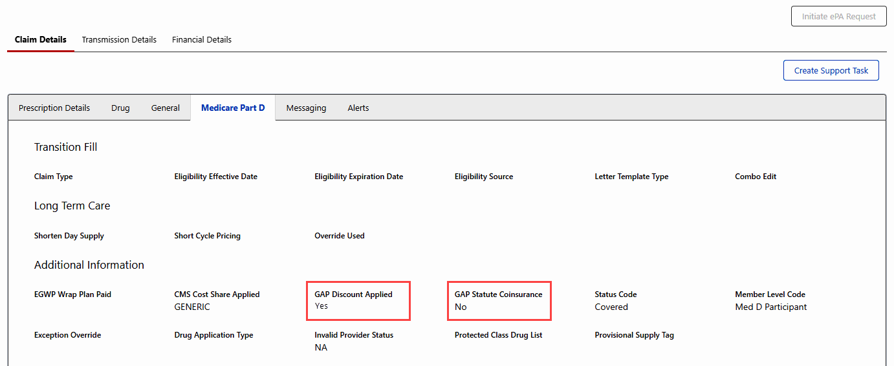

CCR: Review the breakdown of the beneficiary’s cost in the Member Pay and MED D Financials section when reviewing the Financial Details screen. These fields show how the individual drug cost for this prescription moved through the phases including what the beneficiary paid as well as the plan.

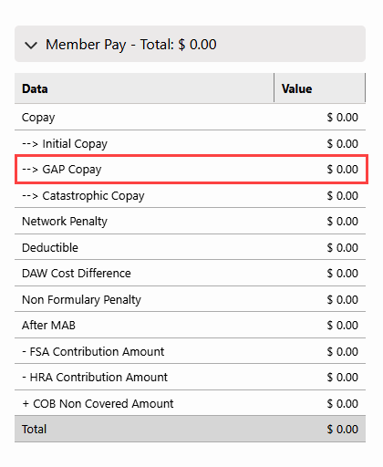

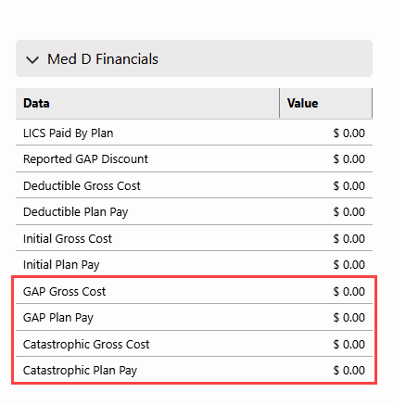

Reminder: Dispensing fees (included at POS) and Vaccine Administration fees cannot be discounted, and a portion of the fees will be the responsibility of the both the beneficiary and the plan sponsor.

Top of the Document

Retroactive Claim Adjustments
- If a retroactive change in a beneficiary’s LIS status occurs, claims will be adjusted accordingly.
- Coverage Gap Discount Program and Generic Gap Coverage logic will be applied accordingly when the claim is reprocessed.
- It would be uncommon for a drug’s application type to change; however, if this does occur, the change will apply to the reprocessed claim.
- Claims that have already processed will not be impacted.

Refer to MED D - Senior Team - Submitting Reconciliation Management Team (RMT) Email.

Top of the Document

Related Documents

Parent SOP: CALL-0048: Medicare Part D Customer Care Call Center Requirements-CVS Caremark Part D Services, L.L.C.
Abbreviations/Definitions: Abbreviations / Definitions

Top of the Document
Not to Be Reproduced or Disclosed to Others without Prior Written Approval
ELECTRONIC DATA = OFFICIAL VERSION / PAPER COPY = INFORMATIONAL ONLY

